
RAMAIAH
INSTITUTE OF TECHNOLOGY
USN | 1 | M | S

(Autonomous Institute, Affiliated to VTU)
Bangalore – 560 054

SEMESTER END EXAMINATIONS – MAY/JUNE 2017

Course & Branch | : | B.E : Computer Science and Engineering | Semester | : | IV
Subject | : | Design and Analysis of Algorithm | Max. Marks | : | 100
Subject Code | : | CS1542/CS413 | Duration | : | 3 Hrs

Instructions to the Candidates:
- Answer one full question from each unit.

 |  | UNIT - I
1. | a) | Identify the stable matching set S for the following set of men and women using Gale-Shapley algorithm. | CO1 | (06)
  Men’s preference list | Women’s preference list
    P | H | I | J | K
    Q | I | J | H | K
    R | J | H | I | K
    S | H | I | J | K
    H | Q | R | S | P
    I | R | S | P | Q
    J | S | P | Q | R
    K | P | Q | R | S
 | b) | Design an algorithm to compute the distance between two points in a plane and deduce the time complexity for the same. | CO1 | (06)
 | c) | - Construct a proof for “If f(n)= θ (g) and g(n)= θ (h) then  f(n)= θ (h)” with an example.  - Construct a proof for “If f is a polynomial of degree d, in which the coefficient a_{d} is positive. Then f = O(n^{d}). | CO1 | (08)
2. | a) | Design an algorithm to find the k-size independent set for a given graph G= (V, E) and compute the time complexity for the same. | CO1 | (06)
 | b) | - Let f and g be two functions that take nonnegative values, and suppose that f= O (g) show that g=Ω (f)  - Let k be a fixed constant, and let f₁, f₂, . . . , f_{k} and h be functions such that fi = O(h) for all i. Then f₁+ f₂ + . . .+ f_{k} = O(h). | CO1 | (08)
 | c) | Consider two players P1 and P2 and nodes in the following order for competitive facility location problem. [10,2,3,10,5,20,25,10,5]. If P1 moves first and then P2, does target bound 10 and 20 are achievable by P2? | CO1 | (06)
 |  | UNIT - II
3. | a) | Construct the BFS traversal tree for the following graph.  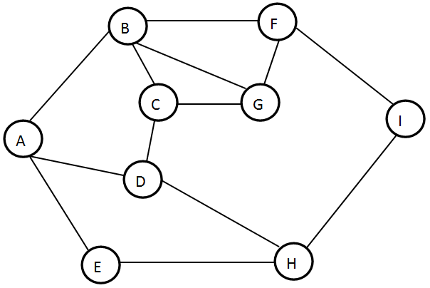 | CO2 | (08)
 | b) | Examine the running time of Merge-Sort using  - Unrolling method ii) Substituting a solution. | CO3 | (05)
 | c) | Design the algorithm for Counting Inversion. | CO3 | (07)
4. | a) | Prove that:  - If G has a topological ordering, then G is a DAG.  - If a directed graph has no cycle, we call it a “Directed Acyclic Graph” or DAG. | CO6 | (06)
 | b) | Discuss the DFS algorithm. List the applications of DFS and BFS. | CO2 | (06)
 | c) | Calculate the number of inversions for the following list of numbers. How many inversions are possible for the worst case input? | CO3 | (08)
  55 | 34 | 50 | 29 | 88 | 77 | 51 | 20 | 60
 |  | UNIT - III
5. | a) | Use Kruskals algorithm to find minimum spanning tree of the graph shown below.  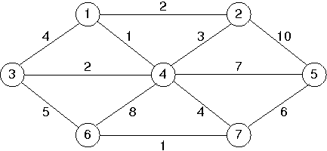 | CO3 | (06)
 | b) | Prove that the set S at any point in the Dijkstras algorithm’s execution. For each u ∈S, the path Pu is a shortest s-u path. | CO3 | (08)
 | c) | Design a greedy algorithm for interval scheduling for the given set of n requests with their start time and finish time. What is the disadvantage of this approach? How can we overcome it? | CO3 | (06)
6. | a) | Solve the below graph using Dijkstras algorithm with source vertex  as A  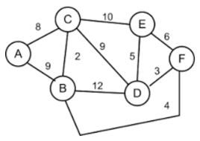 | CO3 | (08)
 | b) |  | CO3 | (06)
  Construct a Huffman tree for the following data:
  Char | A | B | C | D | E
  Probability | 0.25 | 0.15 | 0.25 | 0.1 | 0.25
  - Encode the text A B A C A B A D using generated code.
  - Decode the text whose encoding is 10001011100101.
 | c) | Assume that all edge costs are distinct. Let S be any subset of nodes that is neither empty nor equal to all of V, and let edge e = (v, w) be the minimum cost edge with one end in S and the other in V − S. Then prove that every minimum spanning tree contains the edge e. | CO3 | (06)
 |  | UNIT – IV
7. | a) | Discuss an algorithm to find the shortest path for a given graph G using Bellman Ford algorithm and compute the time complexity for the same. | CO4 | (06)
 | b) | Use Ford Fulkerson algorithm to find the maximum flow path from S to T in a flow network.  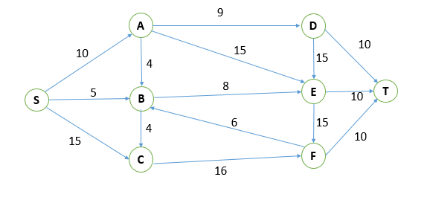 | CO4 | (08)
 | c) | Discuss survey-design problem for a given set of customers and products with an algorithm. | CO4 | (06)
8. | a) | Use Bellman Ford algorithm to find the shortest paths from a single source vertex ‘S’ to all of the other vertices.  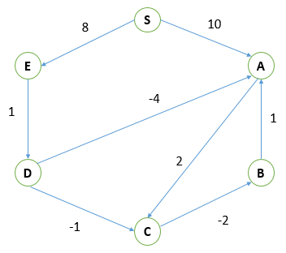 | CO4 | (08)
 | b) | Discuss memoization procedure to determine the maximum weight for a given set of n intervals, and each interval having a weight w. | CO4 | (06)
 | c) | List the intervals that needs to be selected so that maximum weight of the intervals is achieved for the following set of intervals.  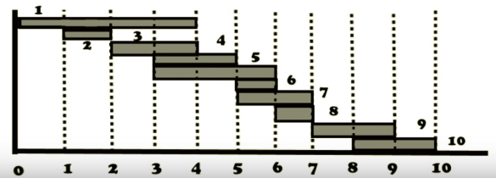 | CO4 | (06)
 |  | UNIT - V
9. | a) | Give an example of an NP complete problem. Explain the strategy used for solving NP complete problem. | CO5 | (10)
 | b) | Discuss Travelling salesman problem and construct a proof for its NP-completeness. | CO5 | (10)
10. | a) | Explain Polynomial time reduction with an example. | CO5 | (10)
 | b) | Define NP complete problems and construct a proof for “Is there a problem in NP that does not belong to P? Does P = NP?” | CO5 | (10)
****************

